Data Analysis Yelp Dataset

April 4, 2016

Ruoping Xu
Ian Leung

Table of Contents
Table of Contents 2
Introduction 3
Sanity Checking Yelp Data Set 4
BCNF, Data Insertion, and Primary and Foreign Key Constraints 4
Date Sanitization 6
Ensuring Accuracy of Data and Statistics 7
Data Analysis 8
User’s Average Star Rating vs Number of Reviews 8
Number of Cities Visited vs Lifestyle 10
Analysis Validation 14
User’s Average Star Rating vs Number of Reviews 14
Number of Cities Visited vs Lifestyle 16

Introduction
The purpose of this report is to perform data cleaning and analysis on the Yelp dataset in order to find patterns and implied information from the dataset. It is expected that based on the data from Yelp reviews, we can extract data about the lifestyles and trends of Yelp users, as well as non-obvious information about the businesses themselves. The extracted information is also validated against randomly selected subsets of the dataset to ensure their validity.

Table Creations and Sanity Checking Yelp Data Set
The yelp dataset contains a large amount of data. As a result, it is quite feasible for certain data to be incorrect or obsolete. This section will describe the strategies and steps taken to ensure the data is accurate and relevant.

BCNF, Data Insertion, and Primary and Foreign Key Constraints
Below is the code used to create the physical schema for the yelp dataset, and sanity check DDL code:
#create tables
CREATE TABLE Tip (`type` VARCHAR(100), business_id VARCHAR(100), text VARCHAR(1000), user_id VARCHAR(100), date DATE, likes INT);
CREATE TABLE `User` (`type` VARCHAR(100), user_id VARCHAR(100), name VARCHAR(100), review_count INT, average_stars VARCHAR(100), yelping_since DATE, fans INT);
CREATE TABLE UserEliteYears(user_id VARCHAR(100),years INT);
CREATE TABLE UserCompliments(user_id VARCHAR(100), profile INT, cute INT, funny INT, plain INT, list INT, writer INT, note INT, photos INT, hot INT, cool INT, more INT, useful INT);
CREATE TABLE UserVotes(user_id VARCHAR(100),funny INT, useful INT, cool INT);
CREATE TABLE UserFriends (user_id VARCHAR(100), friend_id VARCHAR(100));

CREATE TABLE Checkin(`type` VARCHAR(100), business_id VARCHAR(100));
CREATE TABLE CheckinHours(`business_id` VARCHAR(100), `day_hour` VARCHAR(100),`count` INT);

CREATE TABLE Business (type VARCHAR(100), business_id VARCHAR(100), name VARCHAR(100), full_address VARCHAR(1000), review_count INT, city VARCHAR(1000),state VARCHAR(1000), latitude INT, longitude INT, stars FLOAT(10,2),open VARCHAR(10));
CREATE TABLE BusinessHours (business_id VARCHAR(100), day VARCHAR(100), time VARCHAR(10));
CREATE TABLE BusinessCategories (business_id VARCHAR(100),categories VARCHAR(100));
CREATE TABLE BusinessNeighbourhoods (business_id VARCHAR(100),hood_name VARCHAR(100));
CREATE TABLE BusinessAttributes (business_id VARCHAR(100), attribute_name VARCHAR(50), attribute_value VARCHAR(50));

CREATE TABLE Review(user_id VARCHAR(100), review_id VARCHAR(100), business_id VARCHAR(100));
CREATE TABLE ReviewInfo(review_id VARCHAR(100), review_text VARCHAR(10000),review_date DATE, type VARCHAR(10));
CREATE TABLE ReviewVotes(review_id VARCHAR(100), votes__useful INT, votes__funny INT, votes__cool INT);

#add primary keys
ALTER TABLE User ADD PRIMARY KEY (user_id);
ALTER TABLE Business ADD PRIMARY KEY (business_id);
ALTER TABLE Review ADD PRIMARY KEY (review_id);
ALTER TABLE Tip ADD PRIMARY KEY (user_id,business_id);

#foreign keys for tip
ALTER TABLE Tip ADD FOREIGN KEY (business_id) REFERENCES Business(business_id);
ALTER TABLE Tip ADD FOREIGN KEY (user_id) REFERENCES User(user_id);

ALTER TABLE Checkin ADD FOREIGN KEY (business_id) REFERENCES Business(business_id);
ALTER TABLE Review ADD FOREIGN KEY (business_id) REFERENCES Business(business_id);
ALTER TABLE Review ADD FOREIGN KEY (user_id) REFERENCES User(user_id);

#foreignkeys for user
ALTER TABLE UserEliteYears ADD FOREIGN KEY (user_id) REFERENCES user(user_id);
ALTER TABLE UserCompliments ADD FOREIGN KEY (user_id) REFERENCES user(user_id);
ALTER TABLE UserVotes ADD FOREIGN KEY (user_id) REFERENCES user(user_id);
ALTER TABLE UserFriends ADD FOREIGN KEY (user_id) REFERENCES user(user_id);
ALTER TABLE UserFriends ADD FOREIGN KEY (friend_id) REFERENCES user(user_id);

#foreignkeys for checkin
ALTER TABLE Checkin ADD FOREIGN KEY (business_id) REFERENCES Business(business_id);
ALTER TABLE CheckinHours(business_id) REFERENCES Business(business_id);

#foreignkeys for business
ALTER TABLE BusinessHours ADD FOREIGN KEY (business_id) REFERENCES Business(business_id);
ALTER TABLE BusinessNeighbourhoods ADD FOREIGN KEY (business_id) REFERENCES Business(business_id);
ALTER TABLE BusinessCategories ADD FOREIGN KEY (business_id) REFERENCES Business(business_id);
ALTER TABLE BusinessAttributes ADD PRIMARY KEY (business_id, attribute_name);
ALTER TABLE BusinessAttributes ADD FOREIGN KEY (business_id) REFERENCES Business(business_id);

#foreignkeys for review
ALTER TABLE ReviewInfo ADD FOREIGN KEY (review_id) REFERENCES Review(review_id);
ALTER TABLE ReviewVotes ADD FOREIGN KEY (review_id) REFERENCES Review(review_id);

As shown, the Tip dataset is already in BCNF form as each tip is for each business_id-user_id pair. A primary key is created on this relation. The user dataset is only unique upon user_id, and as such, is in BCNF form. Normalization was done to separate data in which multiple entries would be required for each user_id. For example, a user could be elite for years 1950, 1956, 1999. Instead of creating multiple entries into the table under the same user id, a separate table was created to relate each user_id- years pair, thus maintaining BCNF form.
The Check-in dataset does not have any unique identifier, and as such, a foreign key is required to ensure a business exists before inserting checkin information. As multiple checkin-hours could be inserted per checkin, a separate table was created to maintain BCNF form. The business dataset has entries unique to business id, and as such, is in BCNF form already. Normalization was done to separate data in which multiple entries would be required for each business_id. For example, a business could be located in multiple neighbourhoods, and as such, a separate table was cerated to relate each business_id - hood_name pair, thus maintaining BCNF form.
The Review dataset is unique upon a review_id identifier, and also relates a user_id-business_id pair in which a user would leave a review for a business. Foreign keys linking user_id and business_id to existing businesses and users were created to ensure a review would be based on legitimate user and businesses. Similar to the other datasets, separate tables were created to normalize the data.
By inserting the user and business table data first, we establish all legitimate users and businesses that are viable for data insertion. Thus, if any data referencing non-existent user or business ids are inserted, an error would occur. Next, the review table data would be inserted, thus establishing legitimate review_ids providing the review referenced existing users and businesses.
Finally, the rest of the data can be inserted. If any data referenced non-existent businesses, users, or reviews, an error would occur and the entry would be ignored. Below is an ER diagram showing all primary and foreign key relations of the physical schema of the figure above.

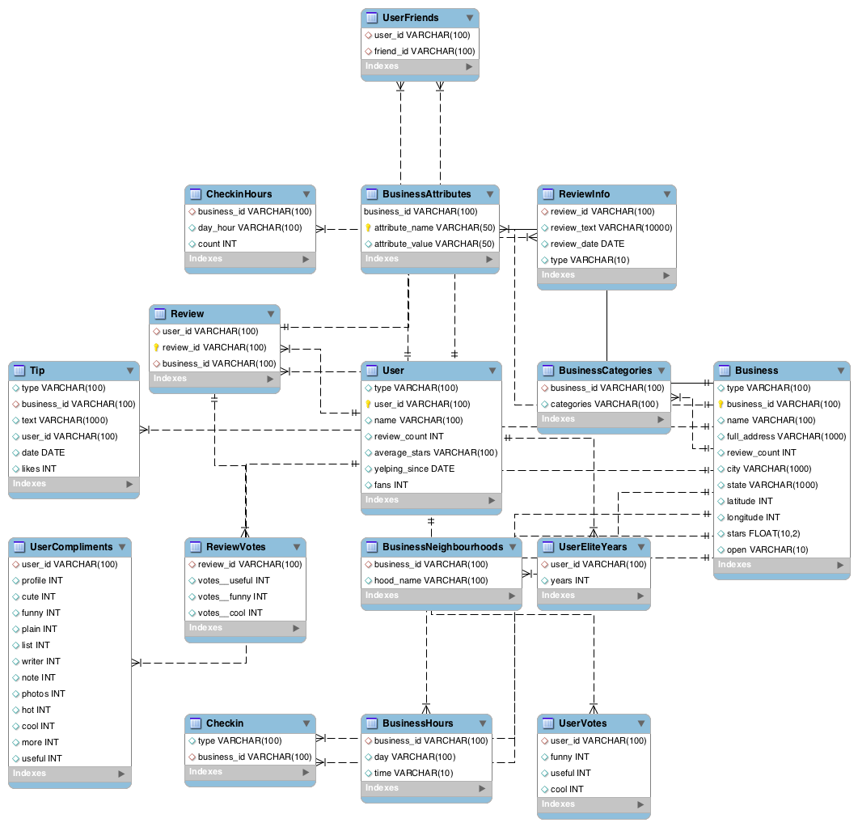

Date Sanitization
Upon examination of the yelp website and how it worked, it was noted that the above sanitization method of using foreign keys would not work for all edge cases. One such case was that users must exist prior to writing reviews and tips for any business. Thus, any reviews or tips recorded by a user prior to the user "yelping_since" date would be false data and must not be inserted. Using foreign keys would not suffice in this case, and additional queries must be run to scan the user and review datasets, and remove entries in cases where the user was created AFTER a particular review or tip was made by said user.
Delete from ReviewVotes where review_id IN (Select review_id from ReviewInfo r inner join User u on r.user_id = u.user_id where r.review_date < u.yelping_since);
DELETE from ReviewInfo where review_id IN (Select review_id from ReviewInfo r inner join User u on r.user_id = u.user_id where r.review_date < u.yelping_since);
DELETE from Review where review_id NOT EXISTS (Select review_id from ReviewInfo);

We can see that we delete entries hierarchically from the review dataset. This is done due to foreign key constraints; thus we must delete from the bottom up. After deleting from the dependant tables ReviewVotes and ReviewInfo all rows that match our above criteria, we finally remove all reviews that don't have Review Information. Upon running the above query, we observe that no rows were removed, as the client-side application functioned as expected, and as such, no improper dates were recorded.
DELETE from Tip t inner join User u on t.user_id = u.user_id where t.date<u.yelping_since;
The Tip case is simpler, as only a single table exists, and there are no foreign key constraints; thus we simply remove all rows were the tip date was before the user creation date.

Ensuring Accuracy of Data and Statistics
Let us consider the case of average stars. The statistic of average stars exist for each business and user. The statistic is calculated by averaging the number of stars per review by a certain user, or on a certain business, rounded to the nearest half star. Even if we assume the value of average stars to be correct, after the above two sanitization techniques, obsolete reviews based on review date or foreign key constraints may be removed. Thus, the average star value may not be accurate after sanitization, and may need to be re-calculated. This could be done with the following queries:
Update User SET user.average_stars = (SELECT ReviewStars.avgstars from
(select user_id, round(avg(stars)/0.5,0)*0.5 as avgstars from Review group by user_id)ReviewStars where ReviewStars.user_id = user.user_id;
Update Business SET business.stars = (SELECT ReviewStars.avgstars from
(select business_id, round(avg(stars)/0.5,0)*0.5 as avgstars from Review group by business_id)ReviewStars where ReviewStars.business_id = Business.business_id;

Here we see that we use a subselect that re-calculates average stars grouped by user and business id. This produces the ReviewStars table with the correct values of average stars for all users and businesses, rounded to the nearest half star. We then run an update by setting the star value of all businesses and users to match the values in the ReviewStars table.
Similar queries can be run for all data and statistics in the yelp dataset to sanitize the data. However, due to the accurate nature of the dataset (0 rows removed by date sanitization, few rows removed by error by foreign key constraint), the star data remained similar. More detailed information can be found in Lab 3 of ECE356 as well. We can safely assume from the above result, that most average and count data would remain relatively accurate without further sanitization, and that the cost of running this many update queries on the entire dataset would be far too large for the potential gain in relevant statistics. We can also assume that periodic updates on statistics are ran by Yelp as well, as new reviews come in, thus further sanitization on our side is not required.

Data Analysis
The data from the Yelp Dataset can be queried to find underlying information about Yelp’s users and businesses. The following sections describe the hypotheses tested for this report, and the reasoning behind the expected results.

User’s Average Star Rating vs Number of Reviews
We expect that in general, if a user has written a large number of reviews, they are more likely to provide an evenly distributed set of ratings and be more fair and critical. However, if a user provides fewer reviews, they are not in the habit of giving out reviews, and would only take the time to review on Yelp if their experience at a business was particularly good or bad.
First, let's examine the statistics for users with less than five reviews (users that do not review often).
Select sum(review_weight) from (select count(review_id) as review_weight, user_id from Review group by user_id having review_weight<5)low_reviewers;
+--------------------+
| sum(review_weight) |
+--------------------+
| 728554 |
+--------------------+

Select sum(review_weight) from (select count(review_id) as review_weight, user_id from Review where stars=1 OR stars=5 group by user_id having review_weight<5)low_reviewers;
+--------------------+
| sum(review_weight) |
+--------------------+
| 605967 |
+--------------------+
We see that there exists 728554 reviews written by reviewers that have written less than 5 reviews in total from the first query. The second query adds an additional filter where we count the number of reviews written by reviewers that have written less than 5 reviews THAT ARE 1 OR 5 STARS ONLY, equal to 605967. We see that the percentage of reviews written by low count reviewers that are high or low is an astounding 83.2%, as predicted in our hypothesis that this value would be very high.
The following examines the same statistics for reviewers that have written MORE than 5 reviews.
Select sum(review_weight) from (select count(review_id) as review_weight, user_id from Review group by user_id having review_weight>=5)high_reviewers;

+--------------------+
| sum(review_weight) |
+--------------------+
| 1496659 |
+--------------------+

Select sum(review_weight) from (select count(review_id) as review_weight, user_id from Review where stars=1 OR stars=5 group by user_id having review_weight>=5)high_reviewers;
+----------+
| count(*) |
+----------+
| 555465 |
+----------+

We see that there exists 1496659 reviews written by HIGH reviewers, but only 555465 of these reviews are one star or five star reviews. Thus, the percentage of reviews that are one star or five stars, written by frequent reviewers is ONLY 37.1% as opposed to the 83.2% written by infrequent reviewers. Thus, our hypothesis that infrequent reviewers leave only excellent or horrible reviews is correct!

Number of Cities Visited vs Lifestyle
A user that travels more often may have different reasons for the frequent travel. We can find what other businesses they frequent in order to determine whether they are travelling for business, leisure, visiting family members, and etc. For example, a user that travels a lot and often stays in hotels is probably travelling for business, whereas someone who does not review hotels is most likely staying with friends or family and is travelling to visit specific people.
The following are queries used to find the correlation between number of cities visited and number of hotels visited.
CREATE VIEW cities_visited AS SELECT Review.user_id, COUNT(DISTINCT city) as distinct_city FROM Business INNER JOIN Review ON Review.business_id = Business.business_id GROUP BY Review.user_id;

CREATE VIEW hotels_visited AS SELECT Review.user_ID, COUNT(Review.business_id) as distinct_business from Review INNER JOIN Categories where Review.business_id=Categories.business_id AND Categories.categories=”hotel” GROUP BY Review.user_ID;
CREATE VIEW nightlife_visited AS SELECT Review.user_ID, COUNT(Review.business_id) as distinct_business from Review INNER JOIN Categories where Review.business_id=Categories.business_id AND Categories.categories=”Nightlife” GROUP BY Review.user_ID;
SELECT * FROM cities_visited AS c INNER JOIN hotels_visited AS h on c.user_id=h.user_id;
The results found in the above queries showed a slight positive correlation between the number of cities visited and number of hotels visited. The following shows a small sample of the large amount of data returned.
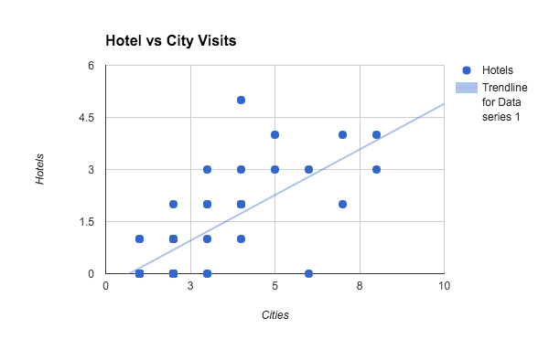
This is expected since more travelling naturally corresponds to more hotel stays. However, we can examine the outliers, i.e. the number of frequent travellers who have a low rate of hotel stays, in order to find information about their travel habits.
Figure # forms the query used to find the correlation of hotel stays and nightlife establishments visited among frequent travellers. The expectation is that people who frequent less nightlife establishments are more likely to be travelling for more family-oriented purposes and will be staying as guests of family and friends. On the other hand, people who visit many nightlife establishments are more likely to be younger tourists or on business trips, and will stay in hotels.
SELECT AVG(* FROM hotels_visited as h INNER JOIN (SELECT c.user_id FROM cities_visited AS c INNER JOIN nightlife_visited AS h on c.user_id=h.user_id where c.distinct_city>5 and c.distinct_city<10) as nightlife where h.user_id=nightlife.user_id;
The results from the above queries showed that there is a slight positive correlation between hotel stays and nightlife business visits among those who have visited between 5 to 10 cities. When we averaged the number of visits categorized as “Nightlife” for those with 5 or more nightlife reviews, and the same number of visits for people who have less than 5 hotel visits, those in the first group had ~3.1 visits versus the ~2.6 of the second group. This shows that amongst frequent travellers, hotel visitors are more likely to also go to businesses like bars and nightclubs.

Analysis Validation

User’s Average Star Rating vs Number of Reviews
We know that the table size for review is given by

select count(*) from Review;
+----------+
| count(*) |
+----------+
| 2225213 |
+----------+

Thus, a simple way to split the data into two equal partitions would be to use LIMIT Table_Size/2 for each of our queries. The Table_Size would be 2225213.
For the top half of the data, we can use LIMIT Table_Size/2:
Select * from Review LIMIT Table_Size/2.
In order to acquire the bottom half of the data, we can simply do a subselect statement where we do:
Select * from Review where review_id NOT EXISTS (Select * from Review LIMIT Table_Size/2).
First, let us run the same queries for the top subset of the data.
Select sum(review_weight) from (select count(review_id) as review_weight, user_id from (select * from review limit 1112606)Reviews group by user_id having review_weight<5)low_reviewers;
+--------------------+
| sum(review_weight) |
+--------------------+
| 459214 |
+--------------------+

Select sum(review_weight)/459214*100 from (select count(review_id) as review_weight, user_id from (select * from review limit 1112606)Reviews where stars=1 OR stars=5 group by user_id having review_weight<5)low_reviewers;
+-------------------------------+
| sum(review_weight)/459214*100 |
+-------------------------------+
| 74.9853 |
+-------------------------------+

Select sum(review_weight) from (select count(review_id) as review_weight, user_id from (select * from review limit 1112606)Reviews group by user_id having review_weight>=5)high_reviewers;
+--------------------+
| sum(review_weight) |
+--------------------+
| 653392 |
+--------------------+

Select sum(review_weight)/653392*100 from (select count(review_id) as review_weight, user_id from (select * from review limit 1112606)Reviews where stars=1 OR stars=5 group by user_id having review_weight>=5)high_reviewers;
+-------------------------------+
| sum(review_weight)/653392*100 |
+-------------------------------+
| 28.5922 |
+-------------------------------+

Here we see that results differ slightly by value, but the general trend of frequent reviewers having a low percentile (28.59%) of extreme reviews vs infrequent reviewers having a high percentile(74.9%) of extreme reviews still holds true. By running the same query on the bottom subset, we receive percent values of 45.41% for frequent reviewers, and 91.1% for infrequent reviewers. We see the large disparity still holds true, and that the average of both sets of data results in our original 37% and 83% from using the full data set! In conclusion, we can see that first half and second half of the data validate each other, albeit with a slight greater variance than expected.

Number of Cities Visited vs Lifestyle
In order to validate the data gathered regarding the lifestyle difference between different groups of frequent travelers, the raw Yelp reviews data was divided into smaller portions of 50% the size of the full dataset. The same queries in the Data Analysis section were performed on the randomly selected subset of data. The resulting analysis showed a similar trend to the previously found results. In fact, the correlation between number of distinct cities found in a user’s review and the number of hotels that the user has reviewed has an even stronger correlation in this subset of review data.
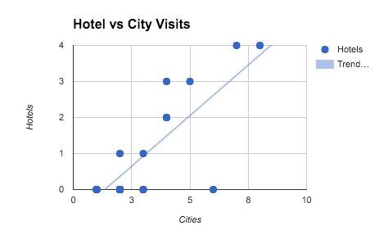
Next, the trend between hotel visits and visits to bars and nightclubs (i.e. “Nightlife”) is recalculated over the data subset only for users with 5 to 10 distinct cities in their reviews. People with less than 5 hotel visits had an average of ~2.9 reviews for nightlife-related businesses, while the rest of the users had a collective average of ~3.2 of the same type of reviews. These results are not completely consistent with the formerly calculated values, but they do show the same trend as before. Therefore the data is conclusive in showing that people who review hotels have a higher likelihood of also reviewing nightlife establishments.

